- POLICY

  - In the event of a fire, Four Counties Addiction Services Team aims to prevent injuries, loss of life and damage to property. This plan is to be used as a guideline for fire prevention as well as what to do in the event of a fire.

  - Preventive Measures to be taken into consideration:

- Every individual shall familiarize themselves with the locations of fire alarms (where applicable), extinguishers, and evacuation points throughout the building they reside in. See Appendices for specific evacuation points/exits for each office location.
- Evacuation points such as hallways, stairways and fire escapes are to be always clear and are not to be used for storage.
- Combustible items such as paper and cardboard and flammable materials are to be kept to a minimum.
- Avoid using long and/or multiple extension cords for electronic devices.
- Refrain from using electrical devices with known problems (ie. frayed electrical cord, or overheating).
- If a gas leak is suspected or you are aware of any damage to building equipment, be sure to report it to your manager or a member of the Joint Health & Safety Committee (JHSC).
- Ensure building maintenance completes routine check of all fire alarms and sprinkler systems at all applicable office locations.
- Fire drills will be held on an annual basis, everyone is to participate and will be notified by Human Resources with advance notice of the date. Except for the following office locations which have independent fire protocols in place: CTS, Campbellford, and Cobourg.
- Fire extinguishers are subject to a routine maintenance contract which is carried out on an annual basis by local fire protection equipment suppliers and the date is indicated on the tag attached to each extinguisher. The extinguishers are also routinely inspected monthly by the JHSC.

  - Fire Alarm Descriptions:

Peterborough Main Office - 130 Hunter Street W, Suite 200
- Employees are notified of a fire by announcing “FIRE” with the telephone paging system from any office telephone by dialing #30.
- If possible, provide the location of the fire/smoke to alert employees and remind them to evacuate building immediately. For example: “Fire located in the large group room, evacuate building immediately”.
- 9-1-1 must be called to report the fire.

Peterborough Consumption Treatment Site (CTS) – 220 Simcoe
- Interconnected fire alarm system. This location has its own designated Fire Safety Plan (FSP) regulated by Article 2.8.1.1. of the Ontario Fire Code. See document for details.

Peterborough Satellite Office – 57 Hunter
- Residential unit – basic residential smoke alarms are installed; alarm will sound if smoke is detected.

Peterborough Satellite Office – 498 Charlotte
- Residential unit – basic residential smoke alarms are installed; alarm will sound if smoke is detected.

Lindsay Office – 37 Lindsay St.
- Interconnected fire alarm system. Alarm will sound when smoke is detected. Since this office is in a shared space, the alarm will sound even if a fire is in another part of the building.

Cobourg Housing Office - 1011 Elgin Street West – 2nd Floor
- Heat/smoke activated alarm in the main hall of the office; alarm will sound if smoke is detected.

Cobourg Counselling Office – 1005 Elgin Street West
- Heat/smoke activated alarm in the main hall of the office; alarm will sound if smoke is detected.

Campbellford Office – c/o Campbellford Memorial Hospital – 146 Oliver Rd, Room 215
- Alarm will sound if smoke is detected. Fire pull station is available to activate the alarm if required. Campbellford Memorial Hospital has a fire protocol that must be followed. See document for details.

1.04 Fire Safety and Evacuation Plan procedures specific to each site will be posted on the back of each doorway for quick reference for employees.

- PURPOSE

  - The purpose of this policy is to identify the guidelines and procedures intended to reduce the risk of harm in the event of a fire that would endanger the lives of employees, clients, and members of the general public.

  - These guidelines are not intended to be all inclusive or to be used at all sites, as written, as it is recognized that each site is unique and requires individualized procedures. Employees that work at shared facilities (hospitals, court houses, Cobourg, Campbellford, Haliburton and Minden) will adhere to policies and procedures as developed by those primary organizations.

- SCOPE
3.01 This policy applies to Fourcast employees, as well as clients, contractors, and visitors who may be on site during the event of a fire.

- RESPONSIBILITY
4.01 Employees are responsible for:
- Providing input as requested to assess specific risks for work areas
- Abiding by the requirements of this policy and applicable procedures.
- Participating in training as required, including fire drills.

4.02 Program Managers are responsible for:
- Assessing specific risks for work areas and reviewing/revising the assessment as is necessary.
- Communicating this policy and procedures to employees within their work area
- Acting as a liaison with police/firefighters if they arrive on site due to a fire
- Following up with employees following a fire to provide support and debriefing

4.03 Human Resources are responsible for:
- Overseeing and managing the development and implementation of policies, procedures, training, and accountability
- Undertaking a risk assessment in conjunction with JHSC to establish protocol for implementing fire safety procedures.
- Ensure that all reasonable measures are taken to eliminate or mitigate risks identified by any incident or threat made to employees or the organization.
- Consult with other parties (i.e. Legal Counsel, Health & Safety consultants, JHSCs, Local Police Services etc.) where necessary.

- DEFINITIONS
Fire Prevention – Refers to having measures and practices in place, directed toward the prevention and suppression of destructive fires that could occur at a Fourcast office.

Fire – Refers to the phenomenon of combustion manifested in light, flame, and heat.

Evacuation - Refers to the act or process of withdrawing from a place in an organized way especially for protection.

- REFERENCES and RELATED STATEMENTS of POLICY and PROCEDURES
Local Fire Department
Ontario Fire Code
Health and Safety Policy
5.14A Hold, Secure and Lockdown Policy

- PROCEDURE

7.01 If You Discover Fire OR Smoke:
- Alert staff by announcing FIRE with the telephone page system, pulling the fire alarm or Alarm occupants of building and yell “FIRE”, (depending on your office location).
- Evacuate the building at the nearest exit. Following the posted evacuation maps and guidelines for your office – located on the back of each office door and listed in the Appendix of this document. Do not use elevators.
  - If a client is in your care, ensure they are evacuated safely.
- Close the office door behind you, placing the ‘evacuated’ door tag on the knob to alert others that you have safely left your office, and no one is behind the closed door, (door tag is applicable for Lindsay and Peterborough Main Office only).
- Proceed to the designated outside meeting area for your office location:
  - Peterborough Main Office (130 Hunter): Parking lot at corner of Brock and Water St.
  - Peterborough Consumption Treatment Site (220 Simcoe): The north side of Parking Lot.
  - Peterborough Satellite (57 Hunter): Back parking lot by the fence. Fire escape takes you behind the building to the parking lot.
  - Peterborough Satellite (498 Charlotte): Bus stop out front on Charlotte St.
  - Cobourg Housing Office: West side of parking lot
  - Cobourg Counselling Office: Front of building. The nearest exit is about 30 ft. to the left of the office. It leads to the side entrance of the building, but everyone is to meet in the front of the building.
  - Campbellford Office: Nearest exit to office exits to the front parking lot. Fire protocol of Campbellford Memorial Hospital to be followed.
  - Lindsay Office (37 Lindsay): Front of the gates to the large dumpster at back of parking lot.
- Once safely evacuated, report the fire by calling 9-1-1.
- Wait for further instructions from Manager, Human Resources or Fire Safety official (depending on work location and who is present).
- All employees will be notified of the situation by management through WhatsApp and/or email.

7.02 Fire Evacuation Safety Guidelines:
- Before opening any doors, feel the door first. If it is hot, don’t open the door. If it isn’t hot, brace yourself against the door, open it slightly, and if heat or heavy smoke is present, close the door and leave by an alternate exit.
- If you can’t leave the room, keep the door closed. Open the windows from the top to let out heat and smoke and from the bottom to let in fresh air. Seal the bottom of your room door and air vents with a rug, blanket, or towel. Then hang a light-colored object (towel, bed sheet, shirt etc.) out the window to attract the Fire Department’s attention. If there is a phone in the room call 911 and report that you are trapped. Be sure to give your building name and location.
- Leave all materials in your room/office to avoid wasting time. Take your keys in case you cannot reach an exit and you have to return to your room.
- Never use an elevator during a fire emergency. A mechanical or electrical failure could leave you trapped at the fire floor or between floors.
- If you are not able to self-evacuate, either proceed to an enclosed stairwell or to a designated area of safe refuge. If you go to an enclosed stairwell, be sure to position yourself so as not to block or impede pedestrian flow or access to the stairwell.
- Only small, contained fires should be attempted to be put out. For example: a fire in a trash can. Locate the closest fire extinguisher and attempt to put out the fire, only if it appears safe to do so.

- If all exits are blocked, go back to your room, close the door, and open the window, as previously described
- Go to a designated meeting area and stay there.
- Once everyone has evacuated and met at the designated meeting point, perform a headcount to ensure all employees are present.
- No persons may re-enter an evacuated building until permitted by emergency personnel.
- All staff has the responsibility of knowing how to alert a fire, the location of fire extinguishers and primary and secondary exit routes for his/her primary place of occupancy while at work.
- Be especially aware of people with disabilities in your building. They may need your help to reach a point of safety such as a stairwell. Report to a manager or human resources the location of the individual.
- Floor plans are posted throughout the buildings for staff and volunteer use.

7.03 Emergency Evacuation Drills/Fire Drills:
- Fourcast Management will facilitate emergency evacuation drills/fire drills for all staff, at a minimum, annually with notice and under varying conditions.
- Drills will be conducted on a day that will ensure maximum employee participation.
- Records of drills will be kept in the emergency response record by Human Resources.
- Employees will receive a tour and be oriented to the evacuation procedure for their specific location during orientation.

7.04 Fire Extinguishment, Control or Confinement
- Most fires start small. Except for explosions, fires can usually be brought under control if they are attacked correctly with the right type and size of extinguisher within the first two minutes.
- In the event a small fire cannot be extinguished with the use of a portable fire extinguisher, or smoke presents a hazard for the operator, the door to the area should be closed to confine and contain the fire.
- If fighting the fire, ensure that the Fire Alarm System has been activated and local Fire Services has been notified prior to any attempt to extinguish the fire.
- Only those persons who are trained and familiar with extinguisher operation may attempt to fight the fire.
- The decision to use a fire extinguisher is one that is made after considering the following:
- Type of fire (Class A, B, C, D or K)
Class A: solid materials such as wood or paper, fabric, and some plastics
Class B: liquids or gas such as alcohol, ether, gasoline, or grease
Class C: electrical failure from appliances, electronic equipment, and wiring
Class D: metallic substances such as sodium, titanium, zirconium, or magnesium
Class K: grease or oil fires specifically from cooking

- Type of fire extinguisher available for the fire
  - Label on the front of the extinguisher confirms what class it is to be used for as well as instructions for use. Most are universal for Class A, B and C.
- Size and intensity of fire
- Size and capacity of the fire extinguisher
- Exit location and clear route away from fire
- When not to fight a fire…
- If the fire could block your only exit
- If the fire is spreading quickly
- If the type or size of the extinguisher is wrong
- If the fire is too large
- If you don’t know how to use the fire extinguisher

- Suggested Operation of Portable Fire Extinguishers
- Remember the (PASS) acronym
P - Pull the safety pin
A - Aim the nozzle
S - Squeeze the trigger handle
S - Sweep from side to side (watch for fire restarting)
- Never re-hang extinguishers after use. Ensure they are properly recharged by a person that is qualified to service portable fire extinguishers and that a replacement extinguisher is provided.
- Keep extinguishers in a visible area without obstructions around them.

7.05 Evacuation Points/Exits
- Please refer to each appendix for site map/floor plan of specific evacuation points/exits of each office location.
Appendix A – Peterborough Main office – 130 Hunter Street, Unit 200
Appendix B – Peterborough Consumption Treatment Site (CTS) – 220 Simcoe
Appendix C – Peterborough Satellite Office – 57 Hunter
Appendix D – Peterborough Satellite Office – 498 Charlotte
Appendix E – Lindsay Office – 37 Lindsay St
Appendix F – Cobourg Housing Office
Appendix G – Cobourg Counselling Office
Appendix H – Campbellford Office

Appendix A – Peterborough Main Office
Upstairs Floor Plan
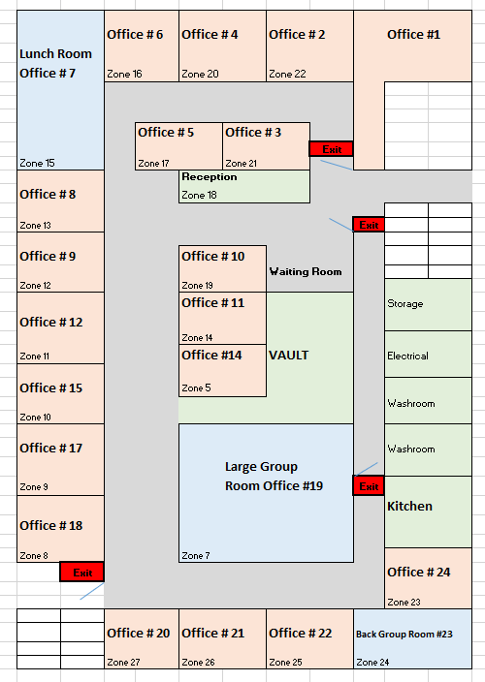

Downstairs Floor Plan
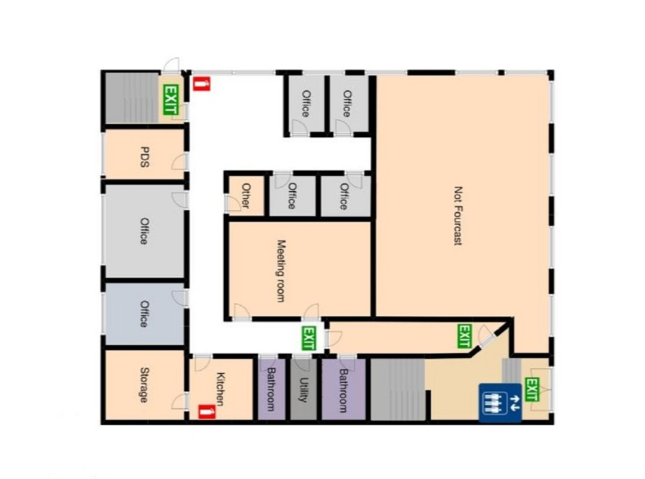

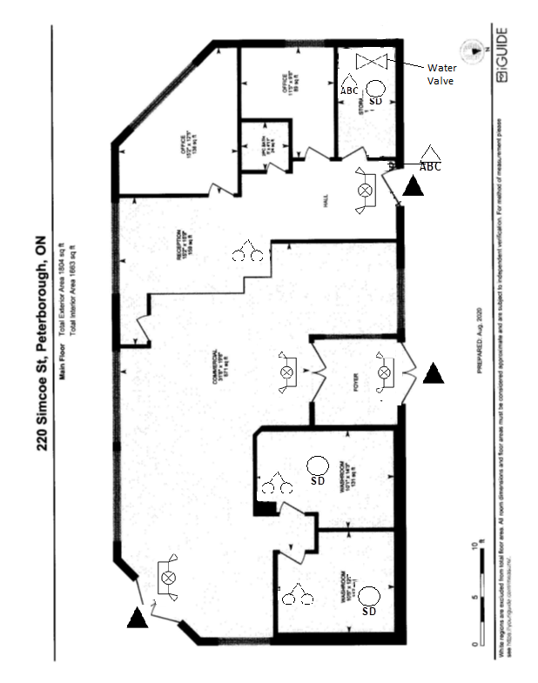
Appendix B – Peterborough CTS

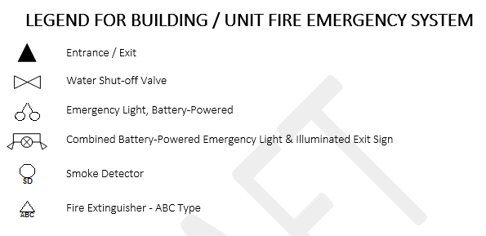

Appendix C – Peterborough Satellite: 57 Hunter

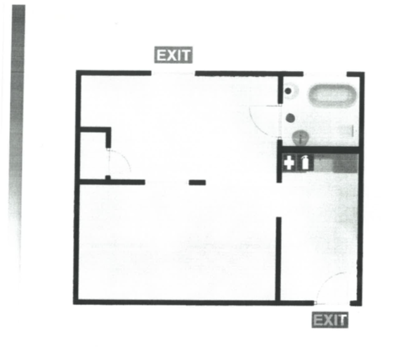

Appendix D – Peterborough Satellite – 498 Charlotte

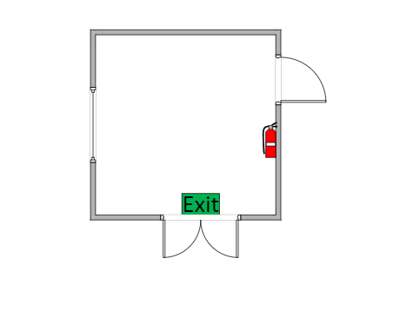

Appendix E – Lindsay Office
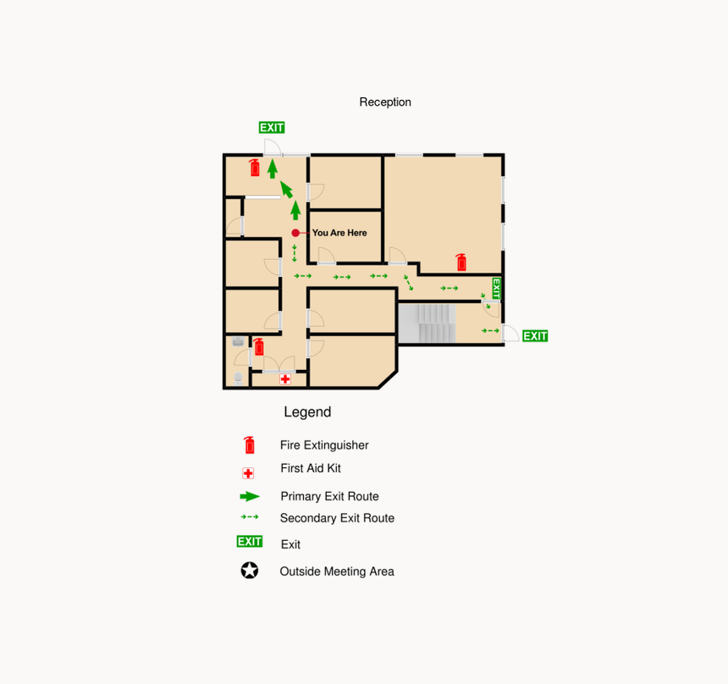

Appendix F – Cobourg Housing Office
** No floorplan**
Only one door to exit. Staff are to use fire extinguisher to clear a safe exit if required and possible. Otherwise, door is to be closed/blocked and 9-1-1 called.

Appendix G – Cobourg Counselling Office
** No floorplan**
The closest fire extinguishers are accessible 50 feet from the office to the right and 30 feet to the left.
The nearest fire pull is about 50 feet from the office to the right.
The nearest exit is about 30 feet to the left of the office, which exits to the side entrance of the building.
Fire drills are regularly scheduled by the building facility.
Appendix H - Campbellford
** No floorplan**
The closest fire extinguisher is accessible in the hallway about 20 feet to the left of the office. The nearest fire pull is approximately 10 feet in the hallway to the right.
The nearest exit is to the left of the office about 50 feet away. Exits out to the front parking lot.
All of the hospitals color codes/safety protocols are hanging on the wall outside of the office to the right.

